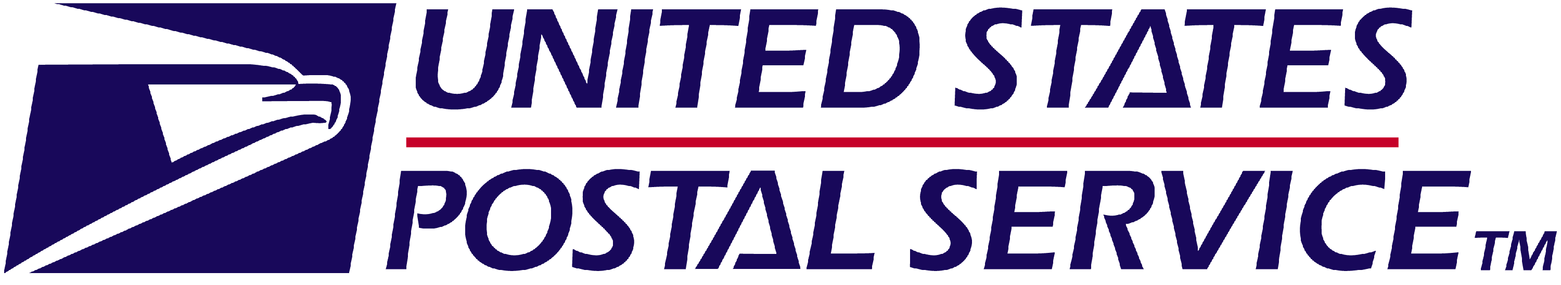 | Pre-Arbitration or Agency  Settlement Worksheet

Instructions: This form expedites processing of lump sum payments from pre-arbitration, pre-trial, and administrative agency settlement agreements. If the payment is for other than lump sum payments (for example, adjustments to hours or benefits), use PS Form 8039, Back Pay Decision/Settlement Worksheet. You must complete sections of this form before the Eagan Accounting Services Center will process the payment. Please print legibly or type when completing this form. A copy of the settlement agreement must accompany this form.
I. Employee Identification
Name (Last, first, MI)  Francis, Pittsnoggle |  |  |  | Employee Identification Number (EIN) (Use SSN if EIN is  Unavailable)  0234221 555-55-5555
Period covered by the settlement:  From: (MM/DD/YYYY) N/A To: (MM/DD/YYYY) N/A |  |  |  | Grievance Number/ Case Number  510-2013-00448X
Designation Activity Code (DES/Act) |  |  |  | Finance Number (to be charged)
Employing Office Address (Number, street, suite, etc.) |  |  |  | Employing Office Telephone Number (including Area Code and Extension)
City | State  CA |  | ZIP+4® | USPS Contact Office Address (number, street, suite, etc.)  1300 Evans Avenue
USPS® Labor Relations or Human Resources, or Law Office Contact  Steven Woods
  City  San Francisco | State  CA | ZIP+4®
City  San Francisco | State  CA |  | ZIP+4® | USPS Contact Telephone Number (including Area Code and Extension)  415-550-5300
II. Settlement Information (for use by Eagan Payroll Services Branch)
Date of Settlement:: (DD/MM/YYYY) |  | Relevant Pay Period:  (PP/YYYY) |  |  | Lump sum amount to be paid:  $
What was the forum of this settlement?
Pre-arbitration
Pre-trial
Equal Employment Opportunity Commission (EEOC)
Merit Systems Protection Board (MSPB)
Other (specify):
III. Interest, Non-wage Income, and Reimbursable Expenses (for use by Eagan Finance Branch)
Note: Issue a separate check for each. Issue IRS Form 1099-INT, Interest Income, for (A). Issue IRS Form 1099-MISC, Miscellaneous Income, for (B). IRS reporting requirements vary for reimbursable expenses listed in item (C). Advise employee to consult with a qualified income tax advisor for more information.
A) Was interest expressly awarded in the settlement?
Yes (interest is computed on the lump sum amount)
No
PS Form 8041, April 2009 (PSN: 7690-07-000-1171)

III. Interest, Non-wage Income, and Reimbursable Expenses (for use by Eagan Finance Branch) -- continued
B) Is any portion of this lump sum payment for non-wage income (e.g. attorneys’ fees) that is excluded from deductions and withholding?
Yes No
If yes, what amount of the lump sum payment is for non-wage income? $
C) Is any portion of this lump sum payment for reimbursable expenses (e.g., travel), including per diem and/or mileage?
Yes No
If yes, what amount of the lump sum payment is for reimbursable expenses? $
IV. Special Instructions
Please list any special instructions: (e.g., mailing instructions or joint name on payments)
NOTE: Lump sum back pay awards are typically mailed to the address of record for the finance number expensed. Alternative mailing arrangements are not available unless the settlement specifically directs other mailing procedures, or the payment is for interest, non-wage income, or reimbursable expenses. Payments for interest, non-wage income and reimbursable expenses will be mailed directly to the employee.

Make check payable to: Francis Pittsnoggle
15 Union Forest Rd
St. Louis, MO 63103

Mail check to: Steven Woods
US Postal Service Law Dept.
1300 Evans Avenue
P.O. Box 883790

V. Signatures
Certifying official’s name and title (please print)
Steven Woods, Deputy Managing Counsel
Signature |  | Date (MM/DD/YYYY)  November 12, 2026
VI. Mailing Instructions
If the amount is less than $1,500, mail to:  Accounting Services  Payroll Services – Pay Location 9631  2825 LONE OAK PARKWAY  EAGAN MN 55121-9631 | If payment is for $1,500 or more, or includes interest, non-wage income, or reimbursable expenses, mail to:  Accounting Services  Financial Processing – Pay Location 9616  2825 LONE OAK PARKWAY  EAGAN MN 55121-9616
PS Form 8041, April 2009, Page 2 of 2

